Kelly St. Pierre
CSC500-1
Critical Thinking, Module 2
February 1, 2026

Pseudocode:

#Part 1: Calculate meal tip, tax, and total

START

Prompt user to input food charge
Store the input as food_charge

Calculate tip as 18 percent of the food charge
Calculate the sales tax as 7 percent of the food charge

Calculate the food charge plus tip
Calculate the food charge plus tax

Calculate the total cost including food charge, tip, and tax

Display food charge with gratuity
Display food charge with sales tax
Display the total cost

END

#Part 2: Determine hour alarm will sound

START

Prompt user to enter current time in 24 hour clock
Store input as current_time

Prompt user to enter the number of hours to wait for alarm
Store input as wait_time

Add current_time and wait_time
Calculate the result modulo 24

Display the time when alarm goes off

END

Source Code:
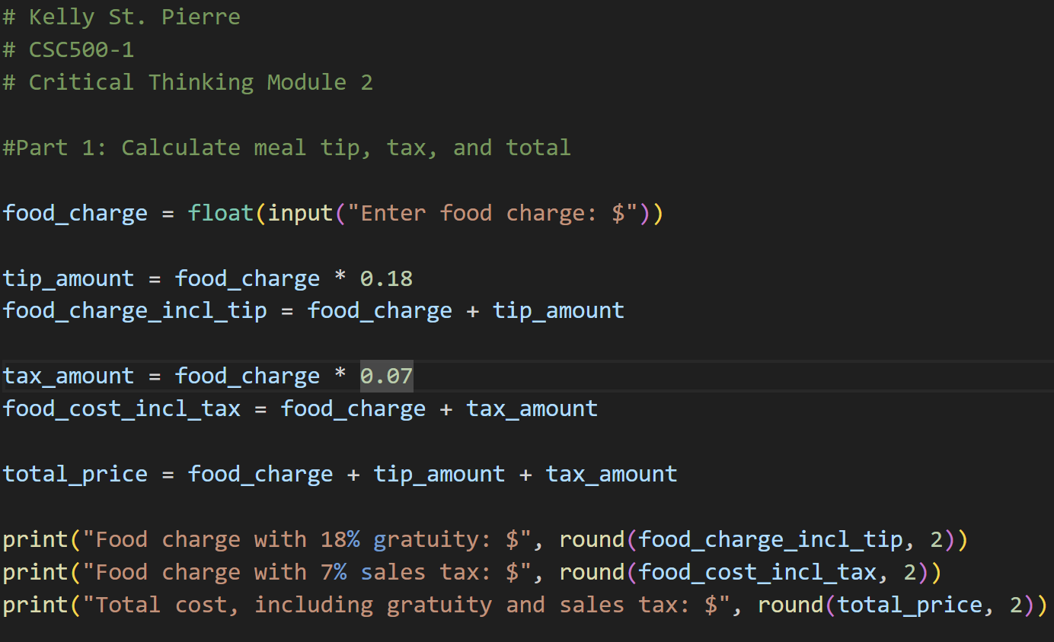
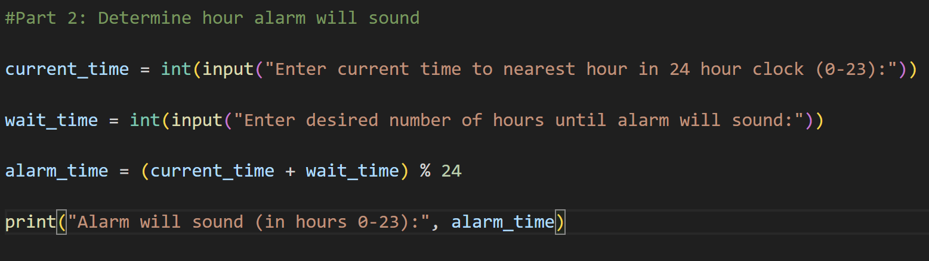

Outputs:
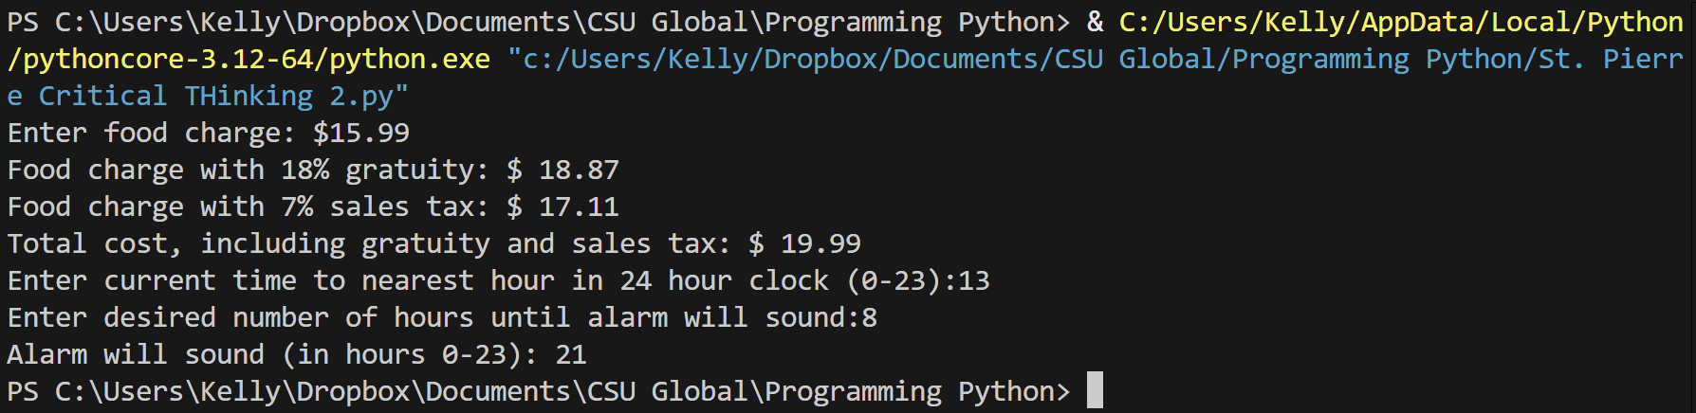

Git Repository:
https://github.com/kellystpierre/Python-Programming.git

